|  |  |
| --- | --- |
| C:\Documents and Settings\mmeo\Local Settings\Temporary Internet Files\Content.IE5\C2BMX0N1\MC900254388[1].wmf |  |

**Bank Name:___________________________ Bank Address: ____________________________________**

|  |  |  |
| --- | --- | --- |
| **Service** | **Summary of Services** | **Pros and Cons** |
| **Regular Savings Accounts**  **(Type of account, minimum balance, interest rates, Fees, etc.)** |  |  |
| **Checking Accounts**  **(Type of account, minimum balance, interest rates, Fees, check services offered etc.)** |  |  |
| **12 mo. Certificates of Deposit (CD)**  **(Type of CD’s, period of time, interest rates, early withdraw penalties, etc.)** |  |  |
| **Money Market Accounts**  **(Monthly fee, services offered, minimal balances, Interest rates, etc.)** |  |  |
| **Final Overall Bank Decision -** Analyze your research from above and review the bank’s services overall service package? After communicating with your group members, how does it compare to their banks? **Summarize your decision using 3 sentences.** | | |

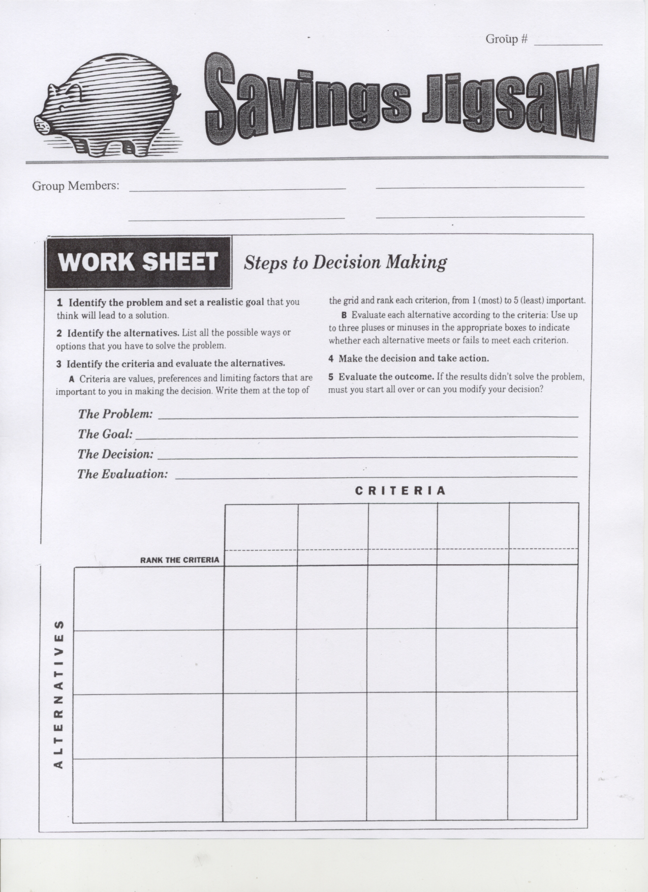

**I need a bank with student friendly services to start saving my money NOW!**

**After 2 or 3 months I will review fees and evaluate the service I have received.**